Missing vrijednosti – (datoteka bank.sav)

U ovom primjeru koristit će se datoteka bank.sav, u kojoj su prikazani podaci o zaposlenicima banke, njihovim socio-demografskim varijablama i zadovoljstvom radom u banci.
SPSS razlikuje dva tipa missing vrijednosti – system-defined i user-defined. Ako se pri unosu podataka ne unese ništa u polje u tablici, SPSS to polje proglašava system-defined missing vrijednošću i označava polje točkom (.). User-defined missing vrijednost se mora eksplicitno navesti u Variable view, pod stupcem Missing.
Zadatak: Pregledati varijable gender, educ, marit, jtype, overall, q1-q9 i utvrditi što one znače. U stupcu Values pronaći vrijednosti za koje je navedeno „No answer“ i te vrijednosti definirati kao missing u stupcu Missing (Discrete missing values).

U izborniku izabrati Analyze > Descriptive statistics > Frequencies > (izabrati varijable gender, educ, marit, jtype, whours, salary, overall, q1-q9) i kliknuti OK
*Pregledati koliko ima missing vrijednosti za svaku varijablu*

Isto tako, U izborniku izabrati Analyze > Missing Value Analysis. Iste varijable podijeliti na kategoričke i kvantitativne i kliknuti OK.
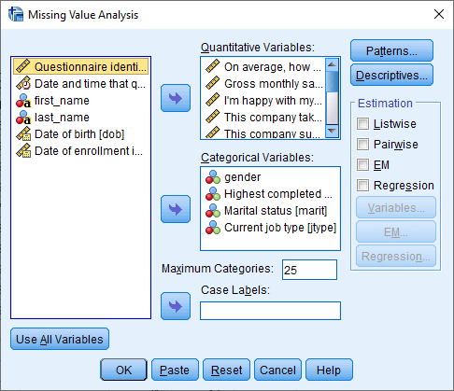
*Pregledati koliko ima missing vrijednosti za svaku varijablu i koji je njihov postotak*

Univariate Statistics
 | N | Mean | Std. Deviation | Missing |  | No. of Extremesª
 |  |  |  | Count | Percent | Low | High
whours | 457 | 31,2407 | 12,92438 | 7 | 1,5 | 1 | 6
salary | 461 | $28,137.48 | $467,773.632 | 3 | ,6 | 0 | 45
overall | 437 | 6,57 | ,887 | 27 | 5,8 | 0 | 4
q1 | 444 | 5,99 | 2,106 | 20 | 4,3 | 0 | 0
q2 | 438 | 4,92 | 2,102 | 26 | 5,6 | 0 | 0
q3 | 434 | 4,90 | 1,680 | 30 | 6,5 | 6 | 4
q4 | 447 | 7,74 | 1,632 | 17 | 3,7 | 0 | 0
q5 | 430 | 5,86 | 1,944 | 34 | 7,3 | 0 | 0
q6 | 441 | 5,88 | 2,014 | 23 | 5,0 | 0 | 0
q7 | 443 | 5,92 | 1,945 | 21 | 4,5 | 11 | 22
q8 | 443 | 4,88 | 1,759 | 21 | 4,5 | 8 | 8
q9 | 440 | 6,97 | 1,799 | 24 | 5,2 | 6 | 0
gender | 464 |  |  | 0 | ,0
educ | 442 |  |  | 22 | 4,7
marit | 447 |  |  | 17 | 3,7
jtype | 443 |  |  | 21 | 4,5
a. Number of cases outside the range (Q1 - 1.5*IQR, Q3 + 1.5*IQR).

Zadatak: Odrediti kojem tipu mehanizma pripadaju missing vrijednosti (MCAR, MAR, MNAR).
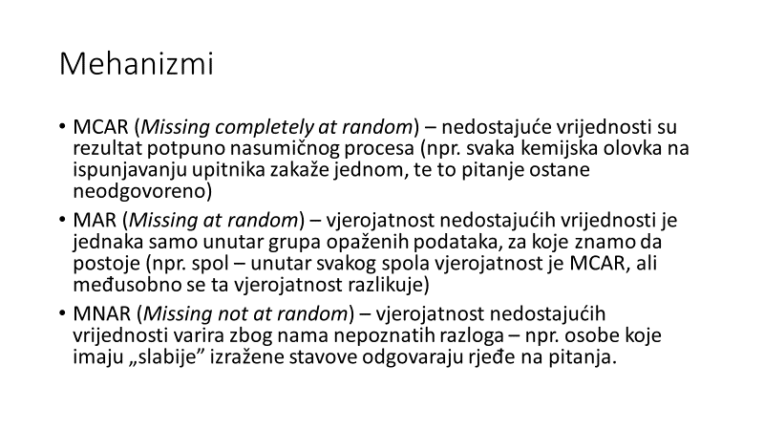
Jesu li podaci MCAR? Littleov test: U izborniku izabrati Analyze > Missing Value Analysis. Iste varijable podijeliti na kategoričke i kvantitativne, „zakačiti“ opciju EM i kliknuti OK

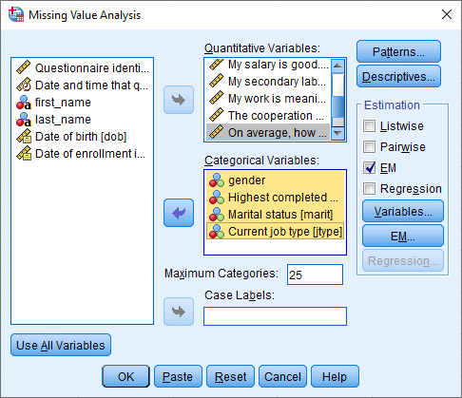

Rezultat:

EM Meansª
whours | salary | overall | q1 | q2 | q3 | q4 | q5 | q6 | q7 | q8 | q9
31,2418 | $30,654.80 | 6,55 | 6,05 | 4,87 | 4,89 | 7,78 | 5,83 | 5,83 | 5,88 | 4,85 | 6,97
- Little's MCAR test: Chi-Square = 362,297, DF = 411, Sig. = ,960

Littleov test nije značajan što sugerira da podaci nedostaju potpuno nasumično.

!!!! Što u slučaju da je Littleov test statistički značajan!!!
U ovom slučaju podaci ne nedostaju nasumično. Postoji nači za utvrđivanje je li mehanizam MAR ili MNAR.
U izborniku izabrati Analyze > Missing Value Analysis. Iste varijable podijeliti na kategoričke i kvantitativne, „zakačiti“ opciju EM, pod linkom Descriptives „zakačiti“ t test with groups formed by indicator variables i Include probabilities in table i kliknuti OK.
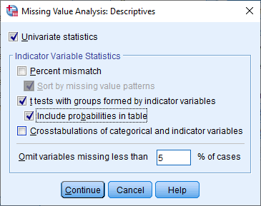

Rezultat:

Separate Variance t Testsª
 |  | q1 | q2 | q3 | q4 | q5 | q6 | q7 | q8 | q9
q2 | t | 1,6 | . | ,6 | -,4 | -,9 | -,6 | 1,1 | ,0 | ,5
 | df | 21,9 | . | 23,2 | 23,4 | 21,6 | 22,7 | 24,0 | 23,8 | 22,0
 | P(2-tail) | ,119 | . | ,543 | ,717 | ,365 | ,587 | ,272 | ,984 | ,608
 | # Present | 423 | 438 | 412 | 425 | 409 | 419 | 420 | 420 | 419
 | # Missing | 21 | 0 | 22 | 22 | 21 | 22 | 23 | 23 | 21
 | Mean(Present) | 6,03 | 4,92 | 4,92 | 7,74 | 5,83 | 5,86 | 5,95 | 4,88 | 6,98
 | Mean(Missing) | 5,24 | . | 4,68 | 7,86 | 6,29 | 6,14 | 5,43 | 4,87 | 6,76
q3 | t | -1,0 | -,6 | . | ,2 | -1,2 | ,2 | -1,1 | ,4 | -,1
 | df | 26,6 | 28,6 | . | 27,3 | 28,7 | 24,4 | 28,8 | 26,4 | 27,9
 | P(2-tail) | ,312 | ,548 | . | ,837 | ,250 | ,815 | ,275 | ,675 | ,925
 | # Present | 419 | 412 | 434 | 422 | 404 | 417 | 417 | 418 | 414
 | # Missing | 25 | 26 | 0 | 25 | 26 | 24 | 26 | 25 | 26
 | Mean(Present) | 5,97 | 4,91 | 4,90 | 7,75 | 5,83 | 5,88 | 5,90 | 4,89 | 6,96
 | Mean(Missing) | 6,44 | 5,15 | . | 7,68 | 6,27 | 5,75 | 6,31 | 4,72 | 7,00
q5 | t | -2,8 | ,7 | 1,2 | -1,7 | . | ,3 | ,4 | ,0 | -1,1
 | df | 37,2 | 33,2 | 34,9 | 30,9 | . | 32,1 | 35,6 | 34,8 | 32,0
 | P(2-tail) | ,008 | ,505 | ,257 | ,101 | . | ,749 | ,711 | ,967 | ,282
 | # Present | 416 | 409 | 404 | 420 | 430 | 412 | 412 | 413 | 412
 | # Missing | 28 | 29 | 30 | 27 | 0 | 29 | 31 | 30 | 28
 | Mean(Present) | 5,94 | 4,94 | 4,93 | 7,71 | 5,86 | 5,88 | 5,93 | 4,88 | 6,94
 | Mean(Missing) | 6,71 | 4,69 | 4,60 | 8,19 | . | 5,76 | 5,81 | 4,87 | 7,29
q9 | t | ,0 | -,3 | ,9 | ,3 | 1,3 | -,3 | -,3 | -,2 | .
 | df | 20,1 | 19,7 | 21,5 | 19,2 | 18,6 | 19,4 | 23,3 | 19,2 | .
 | P(2-tail) | ,987 | ,778 | ,357 | ,792 | ,198 | ,801 | ,764 | ,882 | .
 | # Present | 425 | 419 | 414 | 428 | 412 | 422 | 421 | 424 | 440
 | # Missing | 19 | 19 | 20 | 19 | 18 | 19 | 22 | 19 | 0
 | Mean(Present) | 5,99 | 4,91 | 4,92 | 7,75 | 5,88 | 5,87 | 5,92 | 4,87 | 6,97
 | Mean(Missing) | 6,00 | 5,05 | 4,60 | 7,63 | 5,28 | 6,00 | 6,05 | 4,95 | .
For each quantitative variable, pairs of groups are formed by indicator variables (present, missing).
a. Indicator variables with less than 5% missing are not displayed.

Za svaku kvantitativnu varijablu koja ima više od 5 % missing vrijednosti, SPSS računa t testove između postojećih i missing vrijednosti te varijable (to su grupe) i zasebno vrijednosti svake od ostalih varijabli. Npr. za varijablu q2 (prvi redak, gore lijevo) odredi postojeće i missing vrijednosti (dvije grupe) i uspoređuje rezultate (aritmetičke sredine) podataka na svakoj od ostalih varijabli posebno. Ako svi t testovi nisu značajni (ako je p vrijednost iznad 0.05), onda su podaci MAR. Vidljivo je da kod varijable q5 test jest značajan za varijablu q1, ali već smo pokazali Littleovim testom da su podaci MCAR. Dakle, ako Littleov test pokaže značajnost (Podaci nisu MCAR) i u tablici t testova ima značajnih razlika, onda je mehanizam MNAR.

Rješavanje problema missing vrijednosti
Rješavanje problema missing vrijednosti ovisi o mehanizmu njihova generiranja. U slučaju MCAR, stvar je najjednostavnija. Mnoge analize već nude načine rješavanja problema missing vrijednosti, bez da se vrijednosti imputiraju. Slijedi primjer linearne regresije.
Regresijom se pokušava utvrditi povezanost prediktorskih varijabli gender, educ, marit, jtype, whours, salary i kriterijske varijable overall (općenito zadovoljstvo poslom). Regresija nudi listwise deletion, pairwise deletion i imputaciju aritmetičke sredine.

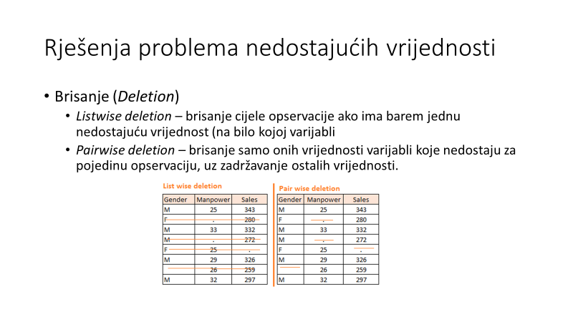
Izabrati Analyze > Regression > Linear, odabrati varijable, pod Statistics zakačiti Descriptives, a pod Options odabrati jednu od opcija
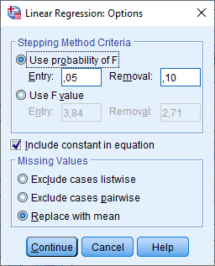
Prikazani rezultati po redu:
- Listwise deletion

Descriptive Statistics
 | Mean | Std. Deviation | N
I'm happy with my job | 6,55 | ,877 | 374
gender | ,43 | ,495 | 374
Highest completed education level | 4,20 | 1,088 | 374
Marital status | 2,17 | ,935 | 374
Current job type | 2,04 | 1,055 | 374
On average, how many hours do you work per week? | 31,3717 | 13,95361 | 374
Gross monthly salary | $33,688.53 | $519,309.221 | 374

Model Summary
Model | R | R Square | Adjusted R Square | Std. Error of the Estimate
1 | ,339ª | ,115 | ,100 | ,831
a. Predictors: (Constant), Gross monthly salary, On average, how many hours do you work per week?, Highest completed education level, Marital status, gender, Current job type

ANOVAª
Model |  | Sum of Squares | df | Mean Square | F | Sig.
1 | Regression | 32,943 | 6 | 5,490 | 7,943 | ,000^{b}
 | Residual | 253,691 | 367 | ,691
 | Total | 286,634 | 373
a. Dependent Variable: I'm happy with my job
b. Predictors: (Constant), Gross monthly salary, On average, how many hours do you work per week?, Highest completed education level, Marital status, gender, Current job type

Coefficientsª
Model |  | Unstandardized Coefficients |  | Standardized Coefficients | t | Sig.
 |  | B | Std. Error | Beta
1 | (Constant) | 5,897 | ,209 |  | 28,239 | ,000
 | gender | -,191 | ,090 | -,108 | -2,121 | ,035
 | Highest completed education level | ,071 | ,044 | ,088 | 1,626 | ,105
 | Marital status | ,020 | ,047 | ,021 | ,415 | ,678
 | Current job type | ,246 | ,045 | ,296 | 5,413 | ,000
 | On average, how many hours do you work per week? | -,004 | ,003 | -,056 | -1,073 | ,284
 | Gross monthly salary | 2,055E-8 | ,000 | ,012 | ,247 | ,805
a. Dependent Variable: I'm happy with my job

Model objašnjava oko 10 % varijance (Model Summary) i značajan je (ANOVA). Muškarci su nezadovoljniji poslom (gender je značajan i negativan), a zadovoljniji su oni na menadžerskim pozicijama (Current job type). Ukupno je analizirano 374 osobe (Descriptives).

- Pairwise deletion

Descriptive Statistics
 | Mean | Std. Deviation | N
I'm happy with my job | 6,57 | ,887 | 437
gender | ,42 | ,494 | 464
Highest completed education level | 4,20 | 1,083 | 442
Marital status | 2,14 | ,936 | 447
Current job type | 2,04 | 1,054 | 443
On average, how many hours do you work per week? | 31,2407 | 12,92438 | 457
Gross monthly salary | $28,137.48 | $467,773.632 | 461

Model Summary
Model | R | R Square | Adjusted R Square | Std. Error of the Estimate
1 | ,306ª | ,094 | ,081 | ,850
a. Predictors: (Constant), Gross monthly salary, On average, how many hours do you work per week?, Highest completed education level, Marital status, gender, Current job type

ANOVAª
Model |  | Sum of Squares | df | Mean Square | F | Sig.
1 | Regression | 30,609 | 6 | 5,102 | 7,056 | ,000^{b}
 | Residual | 295,711 | 409 | ,723
 | Total | 326,320 | 415
a. Dependent Variable: I'm happy with my job
b. Predictors: (Constant), Gross monthly salary, On average, how many hours do you work per week?, Highest completed education level, Marital status, gender, Current job type

Coefficientsª
Model |  | Unstandardized Coefficients |  | Standardized Coefficients | t | Sig.
 |  | B | Std. Error | Beta
1 | (Constant) | 5,922 | ,207 |  | 28,673 | ,000
 | gender | -,140 | ,087 | -,078 | -1,600 | ,110
 | Highest completed education level | ,072 | ,042 | ,088 | 1,697 | ,090
 | Marital status | ,034 | ,046 | ,036 | ,738 | ,461
 | Current job type | ,221 | ,045 | ,262 | 4,938 | ,000
 | On average, how many hours do you work per week? | -,004 | ,003 | -,052 | -1,036 | ,301
 | Gross monthly salary | 2,448E-8 | ,000 | ,013 | ,274 | ,785
a. Dependent Variable: I'm happy with my job

Kod pairwise deletion broj analiziranih jedinica je veći (437-461). I ovdje je model značajan, objašnjava nešto manje varijance (8 %), a spol više nije značajan prediktor.

- Imputacija aritmetičke sredine

Descriptive Statistics
 | Mean | Std. Deviation | N
I'm happy with my job | 6,57 | ,860 | 464
gender | ,42 | ,494 | 464
Highest completed education level | 4,20 | 1,057 | 464
Marital status | 2,14 | ,919 | 464
Current job type | 2,04 | 1,030 | 464
On average, how many hours do you work per week? | 31,2407 | 12,82630 | 464
Gross monthly salary | $28,137.48 | $466,255.704 | 464

Model Summary
Model | R | R Square | Adjusted R Square | Std. Error of the Estimate
1 | ,290ª | ,084 | ,072 | ,829
a. Predictors: (Constant), Gross monthly salary, On average, how many hours do you work per week?, Highest completed education level, Marital status, gender, Current job type

ANOVAª
Model |  | Sum of Squares | df | Mean Square | F | Sig.
1 | Regression | 28,750 | 6 | 4,792 | 6,972 | ,000^{b}
 | Residual | 314,083 | 457 | ,687
 | Total | 342,833 | 463
a. Dependent Variable: I'm happy with my job
b. Predictors: (Constant), Gross monthly salary, On average, how many hours do you work per week?, Highest completed education level, Marital status, gender, Current job type

Coefficientsª
Model |  | Unstandardized Coefficients |  | Standardized Coefficients | t | Sig.
 |  | B | Std. Error | Beta
1 | (Constant) | 5,936 | ,194 |  | 30,533 | ,000
 | gender | -,132 | ,081 | -,076 | -1,639 | ,102
 | Highest completed education level | ,072 | ,040 | ,089 | 1,816 | ,070
 | Marital status | ,033 | ,043 | ,036 | ,776 | ,438
 | Current job type | ,204 | ,042 | ,244 | 4,883 | ,000
 | On average, how many hours do you work per week? | -,003 | ,003 | -,046 | -,967 | ,334
 | Gross monthly salary | 2,554E-8 | ,000 | ,014 | ,308 | ,758
a. Dependent Variable: I'm happy with my job

Kod imputacije arit. sredine je analizirano najviše jedinica (svih 464), objašnjeno je oko 7 % varijance i spol i dalje nije značajan prediktor.
!!!NAPOMENA: nominalne i ordinalne varijable u ovom primjeru su tretirane kao kontinuirane varijable. U suprotnom je potrebno dummy kodiranje!!!

Kod MCAR i MAR preporuča se koristiti EM algoritam (Expectation maximization) za imputaciju vrijednosti, no ova metoda imputira vrijednosti samo za kontinuirane (Scale varijable). Ono što se mora učiniti jest u izborniku EM (Analyze > Missing Value Analysis > EM) zakačiti „Save completed data“ i imenovati datoteku u kojoj će biti spremljeni novi podaci (u ovom slučaju datoteka se zove no_miss.sav).

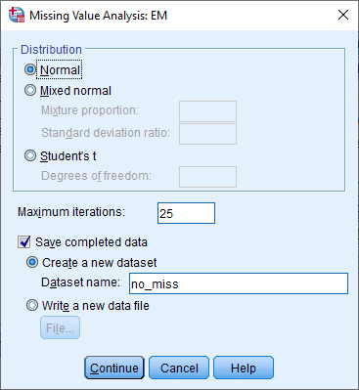

Regresija istovrsna gornjima, s novim podacima i imputacijom aritmetičke sredine (za ne scale varijable) daje ove rezultate.

Descriptive Statistics
 | Mean | Std. Deviation | N
I'm happy with my job | 6,57 | ,873 | 464
gender | ,42 | ,494 | 464
Highest completed education level | 4,20 | 1,057 | 464
Marital status | 2,14 | ,919 | 464
Current job type | 2,04 | 1,030 | 464
On average, how many hours do you work per week? | 31,2549 | 12,82712 | 464
Gross monthly salary | $28,532.97 | $466,281.620 | 464

Model Summary
Model | R | R Square | Adjusted R Square | Std. Error of the Estimate
1 | ,302ª | ,091 | ,079 | ,838
a. Predictors: (Constant), Gross monthly salary, On average, how many hours do you work per week?, Highest completed education level, Marital status, gender, Current job type

ANOVAª
Model |  | Sum of Squares | df | Mean Square | F | Sig.
1 | Regression | 32,191 | 6 | 5,365 | 7,649 | ,000^{b}
 | Residual | 320,551 | 457 | ,701
 | Total | 352,742 | 463
a. Dependent Variable: I'm happy with my job
b. Predictors: (Constant), Gross monthly salary, On average, how many hours do you work per week?, Highest completed education level, Marital status, gender, Current job type

Coefficientsª
Model |  | Unstandardized Coefficients |  | Standardized Coefficients | t | Sig.
 |  | B | Std. Error | Beta
1 | (Constant) | 5,913 | ,197 |  | 30,087 | ,000
 | gender | -,144 | ,081 | -,081 | -1,767 | ,078
 | Highest completed education level | ,084 | ,040 | ,101 | 2,084 | ,038
 | Marital status | ,016 | ,043 | ,017 | ,376 | ,707
 | Current job type | ,215 | ,042 | ,254 | 5,102 | ,000
 | On average, how many hours do you work per week? | -,003 | ,003 | -,050 | -1,043 | ,297
 | Gross monthly salary | 2,530E-8 | ,000 | ,014 | ,302 | ,763
a. Dependent Variable: I'm happy with my job

Rezultati su vrlo slični slučaju kada su sve varijable imputirane aritmetičkom sredinom. To ne treba čuditi jer u slučaju MCAR-a (a naš je takav slučaj) EM algoritam nije mnogo učinkovitiji od imputacije aritmetičkom sredinom svih varijabli.

No u slučajevima MNAR, najbolja metoda je višestruka imputacija (Multiple imputation).
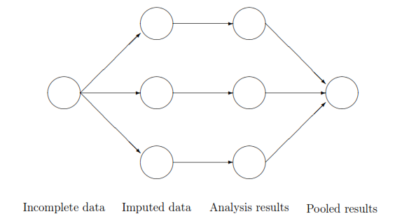

U ovom slučaju potrebno je iz izbornika odabrati Analyze > Multiple imputation > Impute missing data values… i odabrati varijable za imputaciju (one koje ćemo koristiti u analizama), kao i snimiti nove podatke u novu datoteku (ovdje imput.sav). Algoritam će imputirati pet setova podataka, a onda ih spojiti (pool) u jedan.
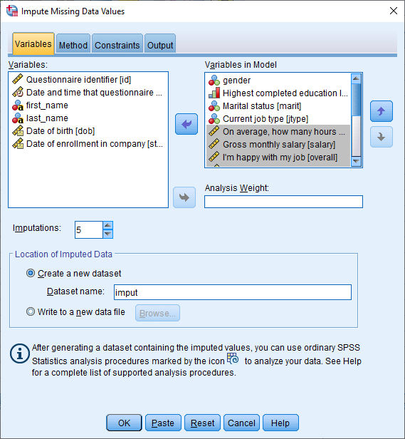

Novi podaci prikazuju originalne podatke i pet imputiranih setova.
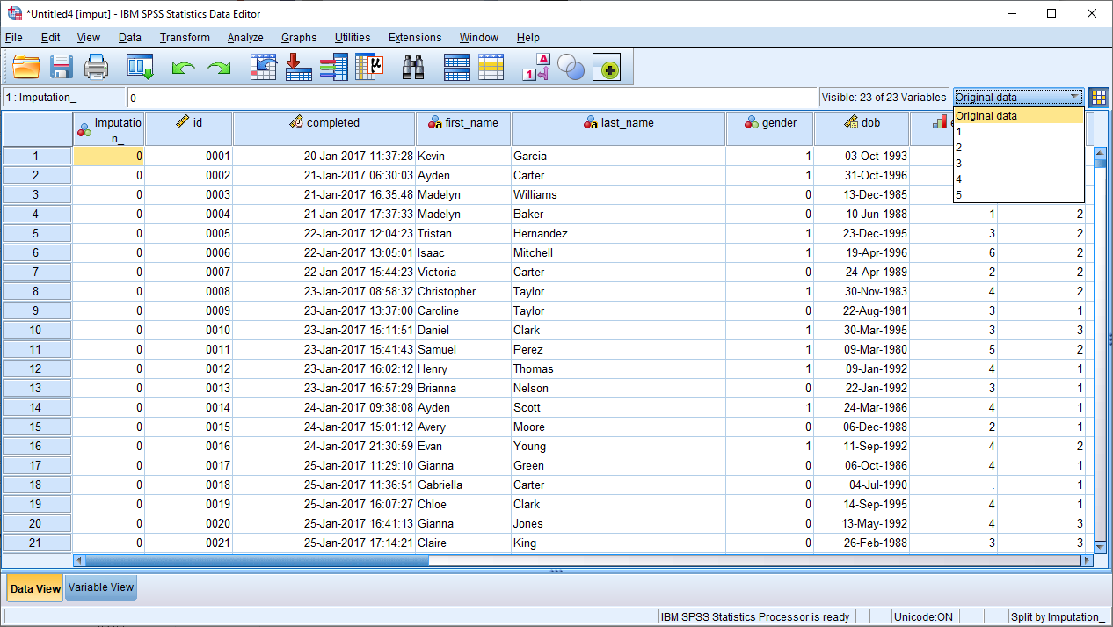

Regresija slična prošlima daje ove rezultate:

Descriptive Statistics
Imputation Number |  | Mean | Std. Deviation | N
Original data | I'm happy with my job | 6,55 | ,877 | 374
 | gender | ,43 | ,495 | 374
 | Highest completed education level | 4,20 | 1,088 | 374
 | Marital status | 2,17 | ,935 | 374
 | Current job type | 2,04 | 1,055 | 374
 | Gross monthly salary | $33,688.53 | $519,309.221 | 374
 | On average, how many hours do you work per week? | 31,3717 | 13,95361 | 374
1 | I'm happy with my job | 6,57 | ,881 | 464
 | gender | ,42 | ,494 | 464
 | Highest completed education level | 4,20 | 1,101 | 464
 | Marital status | 2,14 | ,929 | 464
 | Current job type | 2,04 | 1,057 | 464
 | Gross monthly salary | $33,616.96 | $472,261.709 | 464
 | On average, how many hours do you work per week? | 31,2951 | 12,91289 | 464
2 | I'm happy with my job | 6,56 | ,888 | 464
 | gender | ,42 | ,494 | 464
 | Highest completed education level | 4,19 | 1,099 | 464
 | Marital status | 2,16 | ,950 | 464
 | Current job type | 2,07 | 1,065 | 464
 | Gross monthly salary | $30,271.00 | $467,073.665 | 464
 | On average, how many hours do you work per week? | 31,1920 | 12,94138 | 464
3 | I'm happy with my job | 6,57 | ,887 | 464
 | gender | ,42 | ,494 | 464
 | Highest completed education level | 4,14 | 1,145 | 464
 | Marital status | 2,14 | ,941 | 464
 | Current job type | 2,06 | 1,082 | 464
 | Gross monthly salary | $27,958.20 | $466,996.006 | 464
 | On average, how many hours do you work per week? | 31,1745 | 12,94338 | 464
4 | I'm happy with my job | 6,57 | ,887 | 464
 | gender | ,42 | ,494 | 464
 | Highest completed education level | 4,21 | 1,085 | 464
 | Marital status | 2,16 | ,941 | 464
 | Current job type | 2,06 | 1,071 | 464
 | Gross monthly salary | $27,833.22 | $466,359.408 | 464
 | On average, how many hours do you work per week? | 31,3176 | 12,89786 | 464
5 | I'm happy with my job | 6,57 | ,888 | 464
 | gender | ,42 | ,494 | 464
 | Highest completed education level | 4,18 | 1,114 | 464
 | Marital status | 2,13 | ,937 | 464
 | Current job type | 2,05 | 1,068 | 464
 | Gross monthly salary | $28,445.67 | $466,445.420 | 464
 | On average, how many hours do you work per week? | 31,1483 | 12,96744 | 464
Pooled | I'm happy with my job | 6,57 |  | 464
 | gender | ,42 |  | 464
 | Highest completed education level | 4,18 |  | 464
 | Marital status | 2,15 |  | 464
 | Current job type | 2,06 |  | 464
 | Gross monthly salary | $29,625.01 |  | 464
 | On average, how many hours do you work per week? | 31,2255 |  | 464

Model Summary
Imputation Number | Model | R | R Square | Adjusted R Square | Std. Error of the Estimate
Original data | 1 | ,339ª | ,115 | ,100 | ,831
1 | 1 | ,331ª | ,110 | ,098 | ,837
2 | 1 | ,320ª | ,102 | ,090 | ,847
3 | 1 | ,328ª | ,108 | ,096 | ,843
4 | 1 | ,330ª | ,109 | ,097 | ,842
5 | 1 | ,312ª | ,097 | ,085 | ,849
a. Predictors: (Constant), On average, how many hours do you work per week?, Gross monthly salary, Highest completed education level, Marital status, gender, Current job type

ANOVAª
Imputation Number | Model |  | Sum of Squares | df | Mean Square | F | Sig.
Original data | 1 | Regression | 32,943 | 6 | 5,490 | 7,943 | ,000^{b}
 |  | Residual | 253,691 | 367 | ,691
 |  | Total | 286,634 | 373
1 | 1 | Regression | 39,393 | 6 | 6,566 | 9,378 | ,000^{b}
 |  | Residual | 319,935 | 457 | ,700
 |  | Total | 359,328 | 463
2 | 1 | Regression | 37,261 | 6 | 6,210 | 8,660 | ,000^{b}
 |  | Residual | 327,742 | 457 | ,717
 |  | Total | 365,003 | 463
3 | 1 | Regression | 39,221 | 6 | 6,537 | 9,194 | ,000^{b}
 |  | Residual | 324,902 | 457 | ,711
 |  | Total | 364,123 | 463
4 | 1 | Regression | 39,698 | 6 | 6,616 | 9,323 | ,000^{b}
 |  | Residual | 324,328 | 457 | ,710
 |  | Total | 364,026 | 463
5 | 1 | Regression | 35,462 | 6 | 5,910 | 8,199 | ,000^{b}
 |  | Residual | 329,435 | 457 | ,721
 |  | Total | 364,897 | 463
a. Dependent Variable: I'm happy with my job
b. Predictors: (Constant), On average, how many hours do you work per week?, Gross monthly salary, Highest completed education level, Marital status, gender, Current job type

Coefficientsª
Imputation Number | Model |  | Unstandardized Coefficients |  | Standardized Coefficients | t | Sig. | Fraction Missing Info. | Relative Increase Variance | Relative Efficiency
 |  |  | B | Std. Error | Beta
Original data | 1 | (Constant) | 5,897 | ,209 |  | 28,239 | ,000
 |  | gender | -,191 | ,090 | -,108 | -2,121 | ,035
 |  | Highest completed education level | ,071 | ,044 | ,088 | 1,626 | ,105
 |  | Marital status | ,020 | ,047 | ,021 | ,415 | ,678
 |  | Current job type | ,246 | ,045 | ,296 | 5,413 | ,000
 |  | Gross monthly salary | 2,055E-8 | ,000 | ,012 | ,247 | ,805
 |  | On average, how many hours do you work per week? | -,004 | ,003 | -,056 | -1,073 | ,284
1 | 1 | (Constant) | 5,947 | ,194 |  | 30,647 | ,000
 |  | gender | -,172 | ,081 | -,097 | -2,117 | ,035
 |  | Highest completed education level | ,074 | ,038 | ,093 | 1,945 | ,052
 |  | Marital status | ,008 | ,043 | ,008 | ,182 | ,856
 |  | Current job type | ,243 | ,041 | ,292 | 5,954 | ,000
 |  | Gross monthly salary | 3,092E-8 | ,000 | ,017 | ,374 | ,708
 |  | On average, how many hours do you work per week? | -,004 | ,003 | -,062 | -1,317 | ,189
2 | 1 | (Constant) | 5,887 | ,196 |  | 30,057 | ,000
 |  | gender | -,144 | ,082 | -,080 | -1,744 | ,082
 |  | Highest completed education level | ,077 | ,038 | ,096 | 2,009 | ,045
 |  | Marital status | ,025 | ,042 | ,027 | ,590 | ,556
 |  | Current job type | ,232 | ,041 | ,278 | 5,668 | ,000
 |  | Gross monthly salary | 2,990E-8 | ,000 | ,016 | ,354 | ,724
 |  | On average, how many hours do you work per week? | -,004 | ,003 | -,056 | -1,180 | ,238
3 | 1 | (Constant) | 5,940 | ,190 |  | 31,254 | ,000
 |  | gender | -,134 | ,082 | -,075 | -1,637 | ,102
 |  | Highest completed education level | ,055 | ,036 | ,071 | 1,537 | ,125
 |  | Marital status | ,041 | ,042 | ,043 | ,957 | ,339
 |  | Current job type | ,248 | ,039 | ,303 | 6,347 | ,000
 |  | Gross monthly salary | 1,564E-8 | ,000 | ,008 | ,186 | ,853
 |  | On average, how many hours do you work per week? | -,004 | ,003 | -,065 | -1,384 | ,167
4 | 1 | (Constant) | 5,905 | ,194 |  | 30,362 | ,000
 |  | gender | -,125 | ,082 | -,070 | -1,518 | ,130
 |  | Highest completed education level | ,086 | ,039 | ,105 | 2,195 | ,029
 |  | Marital status | ,000 | ,043 | ,001 | ,011 | ,991
 |  | Current job type | ,241 | ,040 | ,291 | 5,963 | ,000
 |  | Gross monthly salary | 2,065E-8 | ,000 | ,011 | ,245 | ,806
 |  | On average, how many hours do you work per week? | -,004 | ,003 | -,064 | -1,350 | ,178
5 | 1 | (Constant) | 5,932 | ,193 |  | 30,760 | ,000
 |  | gender | -,162 | ,082 | -,090 | -1,965 | ,050
 |  | Highest completed education level | ,064 | ,038 | ,080 | 1,670 | ,096
 |  | Marital status | ,046 | ,043 | ,048 | 1,065 | ,288
 |  | Current job type | ,225 | ,041 | ,271 | 5,499 | ,000
 |  | Gross monthly salary | 2,424E-8 | ,000 | ,013 | ,286 | ,775
 |  | On average, how many hours do you work per week? | -,004 | ,003 | -,056 | -1,176 | ,240
Pooled | 1 | (Constant) | 5,922 | ,195 |  | 30,294 | ,000 | ,021 | ,021 | ,996
 |  | gender | -,147 | ,085 |  | -1,737 | ,083 | ,066 | ,069 | ,987
 |  | Highest completed education level | ,071 | ,040 |  | 1,773 | ,077 | ,112 | ,119 | ,978
 |  | Marital status | ,024 | ,048 |  | ,500 | ,618 | ,222 | ,259 | ,957
 |  | Current job type | ,238 | ,042 |  | 5,698 | ,000 | ,063 | ,065 | ,988
 |  | Gross monthly salary | 2,427E-8 | ,000 |  | ,288 | ,773 | ,007 | ,007 | ,999
 |  | On average, how many hours do you work per week? | -,004 | ,003 |  | -1,274 | ,203 | ,011 | ,011 | ,998
a. Dependent Variable: I'm happy with my job

U ovom slučaju, rezultati su slični kao i EM i imputacija arit. sredine.

